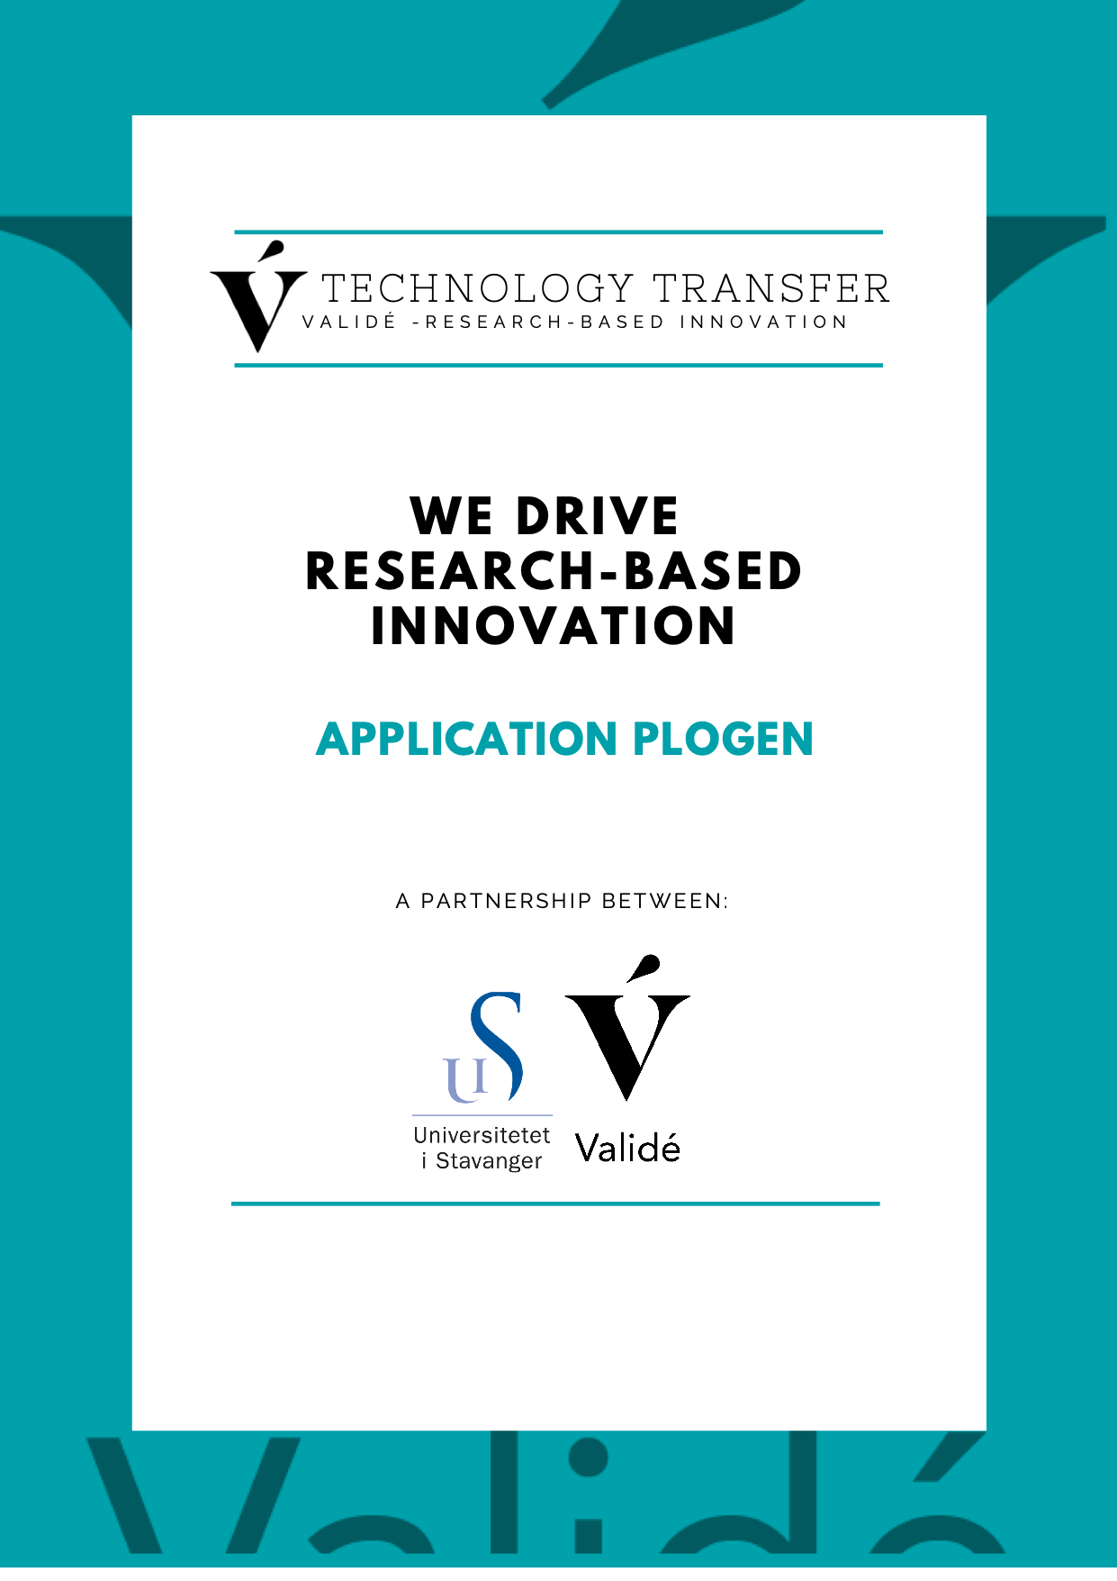

What is Plogen?
Plogen is an initiative to support research-based innovation projects leading to the development of new products and services. Projects can get up to 100 000 NOK.
For more information, please visit https://valide.no/en/plogen

Who can apply?
Applicants should be employees at the University of Stavanger (UiS) throughout the entire project period. The concept or idea must be related to the applicant’s research area.

Evaluation
The degree of innovation of the concept, as well as the applicant's research background and anchoring in past and/or current research projects will be taken into consideration. The applicant's commitment to undertake an innovation project is also important.
The head of department must confirm the application with an email to Validé before sending it to plogen@valide.no so that formalities according to employment are assessed.
Applications will be evaluated as they come.

Reporting
Once the application is approved, the applicant has 15 days to contact the research institute he/she is employed at and start the project. The project is expected to last a maximum of 6 months.
Once the project is completed, the final report must be submitted to Validé within 2 months.
Når prosjektet er avsluttet, må den endelige rapporten sendes til Validé innen 2 måneder. If the project does not start and end in the same calendar year, both the department administration and Validé must be notified within a reasonable time.
The research institution and Validé must also be notified as soon as possible of other changes, such as changes in the project's timeline, scope, employment status, etc. The project can be terminated, and funding can be withdrawn through significant changes in project scope, change in employment status or other important factors.

Questions?
Can be addressed to izaskun@valide.no or kari.birgitte@valide.no

Send this application form in .pdf and .doc format to plogen@valide.no.
Name the files with Plogen, name of the applicant and project title.

APPLICATION PLOGEN

Date:
Title:
Keywords (provide at least 3 distinguishing keywords unique to your project):

Principal investigator:
Name:
Phone:
E-mail:
Workplace(s) and position(s) including position percentage:
1st
2nd
3rd
Department at the research institute:
Research group/institute name:

Subject area (underline one or more of the below and/or add specification under “Other”):

Agriculture
Aquaculture
Biotechnology
Communications
Computer hardware
Construction

Consumer electronics
e-Commerce
Educational technology
Energy
Financial services
Food

Gaming
Health technologies
Health services
Information technology
Life sciences
Material science
Medicine
Nanotechnology
Security
Social networking
Social sciences and humanities
Software
Transport

Other (please specify):

Short, non-confidential summary of the innovation concept (maximum 200 words)

Background
Explain briefly what problem/challenge you are trying to solve and why, and what are the expected results of your research project.
Provide a status of the research project, an overview of publications (scientific literature, doctorate or other dissertation, teaching materials, etc.), and collaborative projects within academia, industry or the public sector, if any. List all relevant activities and planned activities.

Innovation project
Describe the innovation concept and how it builds on your research. What's new in your approach, how will the outcome of the research matter, and who is this important to? What is the final form of the innovation concept (e.g. software, device, method, service, questionnaire, app, design, database, system, etc.)?

Project plan
Describe the goal and expected results for this Plogen project. List all activities and explain through which development steps your innovation project will be realized in addition to this Plow project.

List of activities and budget
The total budget is up to 100 000 NOK including VAT.
Activity | Timeline (from – to) | Cost (net amount + VAT) in NOK
- … | MM-MM/YYYY
- … | MM-MM/YYYY
- … | MM-MM/YYYY
Total

Project team
List all project team members. If the name of the person is not yet known, please write what will be the position of this person (ex: PhD student, master student, technician).
Name | Workplace | Role in the project

Suppliers
List all companies and research institutes involved and their role in the project.
Name | Role in the project

Attachments
Drawings, articles, publications, contracts, etc.
Nr. | Name of the attachment

